**WEEK 7 MANDATORY HANDS-ON**

Exercise - 9

Code:

***#App.css:***

.App {

text-align: center;

}

.App-logo {

height: 40vmin;

pointer-events: none;

}

@media (prefers-reduced-motion: no-preference) {

.App-logo {

animation: App-logo-spin infinite 20s linear;

}

}

.App-header {

background-color: #282c34;

min-height: 100vh;

display: flex;

flex-direction: column;

align-items: center;

justify-content: center;

font-size: calc(10px + 2vmin);

color: white;

}

.App-link {

color: #61dafb;

}

@keyframes App-logo-spin {

from {

transform: rotate(0deg);

}

to {

transform: rotate(360deg);

}

}

***#App.js:***

import React, { useState } from 'react';

import ListofPlayers from './ListofPlayers';

import IndianPlayers from './IndianPlayers';

function App() {

const [flag, setFlag] = useState(true); // 🔄 state to control view

const toggleView = () => {

setFlag(!flag); // Flip the flag on button click

};

return (

<div className="App" style={{ padding: '20px' }}>

<h1>🏏 Cricket App</h1>

<button onClick={toggleView} style={{ marginBottom: '20px' }}>

{flag ? "Switch to IndianPlayers View" : "Switch to ListofPlayers View"}

</button>

{flag ? <ListofPlayers /> : <IndianPlayers />}

</div>

);

}

export default App;

***#App.test.js:***

import { render, screen } from '@testing-library/react';

import App from './App';

test('renders learn react link', () => {

render(<App />);

const linkElement = screen.getByText(/learn react/i);

expect(linkElement).toBeInTheDocument();

});

***#index.css:***

body {

margin: 0;

font-family: -apple-system, BlinkMacSystemFont, 'Segoe UI', 'Roboto', 'Oxygen',

'Ubuntu', 'Cantarell', 'Fira Sans', 'Droid Sans', 'Helvetica Neue',

sans-serif;

-webkit-font-smoothing: antialiased;

-moz-osx-font-smoothing: grayscale;

}

code {

font-family: source-code-pro, Menlo, Monaco, Consolas, 'Courier New',

monospace;

}

***#index,js:***

import React from 'react';

import ReactDOM from 'react-dom/client';

import './index.css';

import App from './App';

import reportWebVitals from './reportWebVitals';

const root = ReactDOM.createRoot(document.getElementById('root'));

root.render(

<React.StrictMode>

<App />

</React.StrictMode>

);

// If you want to start measuring performance in your app, pass a function

// to log results (for example: reportWebVitals(console.log))

// or send to an analytics endpoint. Learn more: https://bit.ly/CRA-vitals

reportWebVitals();

***#ListofPlayer.js:***

import React from 'react';

function ListofPlayers() {

const players = [

{ name: "Virat", score: 85 },

{ name: "Rohit", score: 40 },

{ name: "Dhoni", score: 90 },

{ name: "Raina", score: 30 },

{ name: "Gill", score: 75 },

{ name: "Bumrah", score: 65 },

{ name: "Rahul", score: 20 },

{ name: "Pant", score: 95 },

{ name: "Jadeja", score: 70 },

{ name: "Shami", score: 60 },

{ name: "Ashwin", score: 45 }

];

const filtered = players.filter(player => player.score < 70); // arrow function

return (

<div>

<h2>All Players</h2>

<ul>

{players.map((player, index) => (

<li key={index}>{player.name} - {player.score}</li>

))}

</ul>

<h2>Players with score below 70</h2>

<ul>

{filtered.map((player, index) => (

<li key={index}>{player.name} - {player.score}</li>

))}

</ul>

</div>

);

}

export default ListofPlayers;

***#IndianPlayers.js:***

import React from 'react';

function IndianPlayers() {

const allPlayers = ["Kohli", "Rohit", "Dhawan", "Shreyas", "Surya", "Hardik"];

// 🟦 Even Index Players (0, 2, 4...)

const evenTeam = allPlayers.filter((_, index) => index % 2 === 0);

// 🟥 Odd Index Players (1, 3, 5...)

const oddTeam = allPlayers.filter((_, index) => index % 2 !== 0);

// 🧩 Destructuring example

const [firstPlayer, secondPlayer, ...others] = allPlayers;

// 🟨 Merge Arrays (T20 + Ranji)

const T20Players = ["Iyer", "Kishan"];

const RanjiPlayers = ["Pujara", "Rahane"];

const mergedTeam = [...T20Players, ...RanjiPlayers];

return (

<div>

<h2>🟦 Even Team Players</h2>

<ul>

{evenTeam.map((player, index) => (

<li key={index}>{player}</li>

))}

</ul>

<h2>🟥 Odd Team Players</h2>

<ul>

{oddTeam.map((player, index) => (

<li key={index}>{player}</li>

))}

</ul>

<h2>🧩 Destructuring</h2>

<p>First Player: {firstPlayer}</p>

<p>Second Player: {secondPlayer}</p>

<p>Remaining: {others.join(", ")}</p>

<h2>🟨 Merged Team (T20 + Ranji)</h2>

<ul>

{mergedTeam.map((player, index) => (

<li key={index}>{player}</li>

))}

</ul>

</div>

);

}

export default IndianPlayers;

Output:

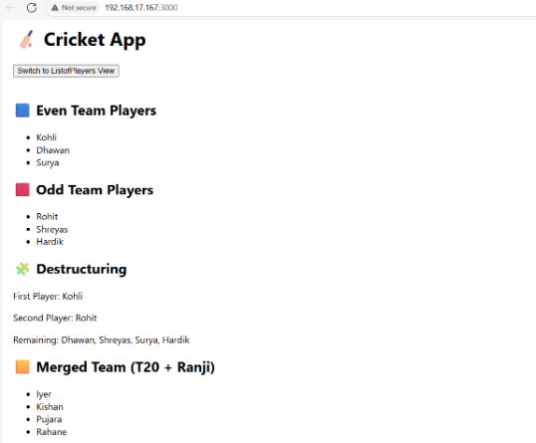

Exercise -10

Code:

**Required files besides mandatory one’s which were included in week 9:**

***#OfficeList.js:***

import React from 'react';

// Heading element using JSX

const heading = <h1>🏢 Office Space Rental Listings</h1>;

// Image element using JSX

//onst imageUrl = "https://via.placeholder.com/600x200?text=Office+Space+Rental";

//const imageElement = <img src={imageUrl} alt="Office Space" style={{ width: '100%', borderRadius: '8px' }} />;

// List of office objects

const offices = [

{ name: "WeWork", rent: 45000, address: "Bangalore, MG Road" },

{ name: "Regus", rent: 72000, address: "Hyderabad, Banjara Hills" },

{ name: "91Springboard", rent: 55000, address: "Mumbai, Andheri" },

{ name: "Smartworks", rent: 80000, address: "Delhi, Connaught Place" }

];

function OfficeList() {

return (

<div style={{ padding: '20px', fontFamily: 'Arial' }}>

{heading}

<ul style={{ listStyleType: 'none', padding: 0 }}>

{offices.map((office, index) => {

// Conditional inline style for rent

const rentStyle = {

color: office.rent < 60000 ? 'red' : 'green',

fontWeight: 'bold'

};

return (

<li key={index} style={{ marginBottom: '20px', padding: '10px', border: '1px solid #ccc', borderRadius: '8px' }}>

<h3>{office.name}</h3>

<p><strong>Address:</strong> {office.address}</p>

<p><strong>Rent:</strong> <span style={rentStyle}>₹{office.rent}</span></p>

</li>

);

})}

</ul>

</div>

);

}

export default OfficeList;

Output:

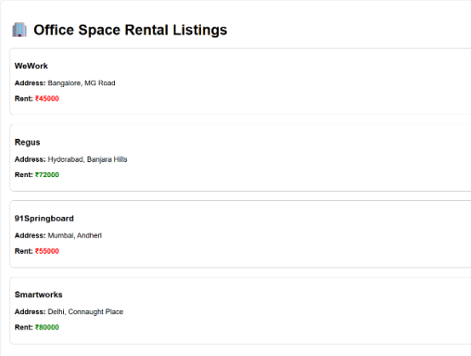

Exercise – 11

Code:

***#Counter.js:***

import React, { Component } from 'react';

class Counter extends Component {

constructor() {

super();

this.state = {

count: 0

};

}

incrementCount = () => {

this.setState(prev => ({ count: prev.count + 1 }));

};

decrementCount = () => {

this.setState(prev => ({ count: prev.count - 1 }));

};

sayHello = () => {

alert("Hello! You clicked the increment button.");

};

handleIncrement = () => {

this.incrementCount();

this.sayHello();

};

sayWelcome = (message) => {

alert(`Welcome message: ${message}`);

};

handleSynthetic = (event) => {

alert("I was clicked");

console.log("Synthetic Event:", event);

};

render() {

return (

<div>

<h2>Counter: {this.state.count}</h2>

<button onClick={this.handleIncrement}>Increment</button>

<button onClick={this.decrementCount}>Decrement</button>

<br /><br />

<button onClick={() => this.sayWelcome("Welcome to the Event App")}>Say Welcome</button>

<br /><br />

<button onClick={this.handleSynthetic}>Synthetic Event</button>

</div>

);

}

}

export default Counter;

***#CurrencyConverter.js:***

import React, { useState } from 'react';

function CurrencyConvertor() {

const [rupees, setRupees] = useState('');

const [euros, setEuros] = useState('');

const handleSubmit = () => {

if (!isNaN(rupees)) {

const euroValue = (parseFloat(rupees) / 90).toFixed(2);

setEuros(euroValue);

} else {

alert("Please enter a valid number");

}

};

return (

<div>

<h2>Currency Convertor</h2>

<label>Enter amount in ₹ Rupees: </label>

<input

type="text"

value={rupees}

onChange={(e) => setRupees(e.target.value)}

/>

<button onClick={handleSubmit}>Convert to € Euro</button>

{euros && <p>Converted Amount: € {euros}</p>}

</div>

);

}

export default CurrencyConvertor;

Output:

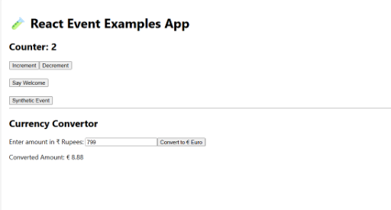

Exercise – 12

***#Guest.js:***

import React from 'react';

function Guest() {

return (

<div>

<h2>Welcome Guest ✈️</h2>

<p>You can view flight details but must log in to book tickets.</p>

</div>

);

}

export default Guest;

Output:

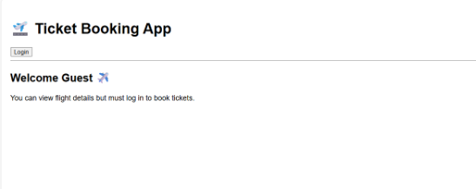

Exercise – 13

Code:

***#BlogDetails.js:***

import React from 'react';

function BlogDetails() {

const blogs = [

{

title: 'React Learning',

author: 'Stephen Biz',

content: 'Welcome to learning React!'

},

{

title: 'Installation',

author: 'Schewzdenier',

content: 'You can install React from npm.'

}

];

return (

<div className="section">

<h2>Blog Details</h2>

<div className="card-row">

{blogs.map((blog, i) => (

<div className="card" key={i}>

<h3>{blog.title}</h3>

<p><strong>{blog.author}</strong></p>

<p>{blog.content}</p>

</div>

))}

</div>

</div>

);

}

export default BlogDetails;

***#BookDetails.js:***

import React from 'react';

function BookDetails() {

const books = [

{ title: 'Master React', price: 670 },

{ title: 'Deep Dive into Angular 11', price: 800 },

{ title: 'Mongo Essentials', price: 450 }

];

return (

<div className="section">

<h2>Book Details</h2>

<div className="card-row">

{books.map((book, i) => (

<div className="card" key={i}>

<h3>{book.title}</h3>

<p>₹{book.price}</p>

</div>

))}

</div>

</div>

);

}

export default BookDetails;

***#CourseDetails.js:***

import React from 'react';

function CourseDetails() {

const courses = [

{ name: 'Angular', date: '4/5/2021' },

{ name: 'React', date: '6/3/2021' }

];

return (

<div className="section">

<h2>Course Details</h2>

<div className="card-row">

{courses.map((course, i) => (

<div className="card" key={i}>

<h3>{course.name}</h3>

<p>{course.date}</p>

</div>

))}

</div>

</div>

);

}

export default CourseDetails;

Output:

